A Project Report

On

**Art gallary**

Developed At

**Harivandana College**

For the fulfillment of the requirements for the

**BCA – 6th Semester [2023]**

**Developed By**

**Mehta Drashti**

Submitted To



**DEPARTMENT OF COMPUTER SCIENCE**

**-: Under the Guidance of :-**

**Dr.AshwinRathod (Head of Department)**

**Prof. DharmendraAmbani (Project In-charge)**

Certificate Page

**ACKNOWLEDGEMENT**

I have been able to submit my report in **“Art gallary”** successfully due to the guidance provided by my lecturers of Computer Departments.I thank to all our Computer Department Faculty, **Harivandana**College, Rajjkot**Dr.AshwinRathod** for giving us this opportunity to make this report. Guidance  **Prof. DharmendraAmbani,**who had guided me, regularly supervised my project. I would like to express my deep gratitude to the all staff members, for their valuable suggestion and co-operation.I acknowledgement all my friends for their innumerable guidelines and suggestions. My all lab faculty they spared time for me whenever I need it. They strengthened my fundamentals and basic concepts with their experience and through knowledge. I thanks all of you once again.

**INDEX**

1. **Project Profile.…………………………………………………………5**
2. **Introduction**
   1. Android ....................………………………………………………..**6**
   2. Purpose..………………………………………………………..**........7**
3. **System Requirements**
   1. Software Requirements………................…………........…..............**8**
   2. Programming Language , Tools and Technology ………….............8
   3. Information Gathering………………………………………............11
4. **Software Requirements Specification Document**...............................12
5. **UML Diagrams**
   1. 0 Level DFD………………………………………………………...**14**
   2. Use Case Diagram…………………………………………………..**16**
6. **System Design**
   1. Data Dictionary………………………………………………….....**18**
   2. User Interface……………………………………………………....**20**
7. **Testing………………………………………………......……………...26**
8. **Future Work........................................................................................28**
9. **References...........................................................................................29**
10. **Conclusion...........................................................................................30++**

**1. PROJRCT PROFILE**

**Course/sem :BCA sem-6**

**Year : 2022/2023**

|  |  |  |  |  |  |  |  |  |
| --- | --- | --- | --- | --- | --- | --- | --- | --- |
| **No.** | **Title** | **Detail** | | | | | | |
| 2 | Project Title | Art gallary | | | | | | |
| 3 | Project Type | Art gallary | | | | | | |
| 4 | Front End Tools | Java , Android | | | | | | |
| 5 | Back End Tools | MySQL | | | | | | |
| 6 | Group member | One | | | | | | |
| 7 | Member Name | **Roll** | | | **Name** | | | |
| 32 | | | Mehta Drashti | | | |
| 8 | H/W Requirement | **H/W** | | **Server Side** | | | | **Client Side** |
| Processor | | Intel 2D | | | | Intel 2D |
| RAM | | 2 GB | | | | 2 GB |
| Hard Disk | | 40 GB | | | | 20 GB |
| 9 | S/W Requirement | **Server side** | | | | | | |
| Front End | | | | Java , Android | | |
| Back End | | | | MySQL | | |
| OS | | | | Android | | |
| Web Server | | | | Apache | | |
| **Client Side** | | | | | | |
| OS | | | | Android | | |
| 10 | Other Software Requirement | * Android Studio * Microsoft Word * XAMPP | | | | | | |
| 11 | Functionality of Project | **No.** | **Admin** | | | | **User** | |
| 2 | Add art | | | | View art Category | |
| 3 | Manage and Download | | | | Download art Image | |
|
|
| 12 | Submitted By | Mehta Drashti | | | | | | |

**2.. INTRODUCTION :**

**2.1 Android :**

Android is an operating system and programming platform developed by Google for mobile phones and other mobile devices, such as tablets. It can run on many different devices from many different manufacturers. Android includes a software development kit (SDK) that helps you write original code and assemble software modules to create apps for Android users. Android also provides a marketplace to distribute apps. All together, Android represents an ecosystem for mobile apps.The first beta version of the Android Software Development Kit (SDK) was released by Google in 2007 where as the first commercial version, Android 1.0, was released in September 2008.

On June 27, 2012, at the Google I/O conference, Google announced the next Android version, 4.1 Jelly Bean. Jelly Bean is an incremental update, with the primary aim of improving the user interface, both in terms of functionality and performance.

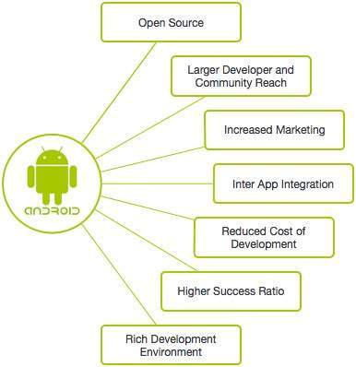

**2.2 Purpose :**

I will be developing an android application to display Art gallary. The app will have a feature to add those art image to favorites.

I will be first creating a database using MySQL to store all the arts, and then I will be importing this database into our application using JSON Parsing and will be using it. Now let’s take a look at the key features of this application that we will be developing and also take a look at what you’ll be learning from this.

**Features to develop:**

* ***Home Page***– with buttons to navigate to list of art names, favorites page, privacy policy page.
* ***Arts List Page***– here all the Arts will be listed and their preview will be available to the users.
* ***Display Arts Page***–  singleArts will be displayed here. Users can add a Arts download a Arts image from here. They will also be able to navigate to the next the Arts from here.
* ***Download Image***–  users will be able to download the image to the gallary.

**3. SYSTEM REQUIREMENTS**

**3.1 Software Requirement:**

|  |  |
| --- | --- |
| **SOFTWARE** | **REQUERIMENT** |
| Front-end | Android , Java |
| Back-end | MYSQL |
| Project Tool | Android Studio |
| Documentation Tool | MS Word 2010 |

**3.2 Programming Languages, Tools and Technologies:**

**1) Android Studio:**

Android Studio is exclusively designed for developing Android applications. It consists of all Android SDK tools to design, develop, maintain, test, debug and publish our app. The IDE is designed very efficiently which makes the developer’s job easy.

It also supports the IntelliJ IDE, the main idea behind this IDE is that it automatically senses the variables, methods, classes, built-in functions or it could be anything else when we press the first letter of it.

Say, suppose we declared few variables or methods that starts with an ‘S’, it automatically senses everything that starts with an ‘S’ and makes suggestions. It also supports Git as a version control system to maintain the app changes and push them into github. All java files, layout files (for design) are integrated into a single project easily. After the completion of project, the whole application could be put as an .APK (Android Package) file, in which we can run that APK file in any device and use the application.

**1.2 ) Android Software Development Kit (SDK):**

One of the main tools used in developing android applications, as it packages many core features into one SDK and it can be used in the application easily. This helps us to avoid writing lot of code, and building applications faster.

**1.3)Android Debug Bridge (ADB):**

Android SDK uses ADB tool as a connection device which allows us to connect the Android Devices or Emulator with the machine via USB. After developing or while developing applications, we can connect with the device to check how the application runs. Later, we can debug and run the applications.

**1.4) Gradle Build:**

Gradle Scripts are the recent feature that is added to Android Studio. It is basically an automated build system which is used to automate the various phases involved in designing an application that includes design, development, test, debug, and publish. We need to configure the project and modules by mentioning all the supported jar files, SDK’s, version name, level, compiled SDK version, build tools version. to ensure that the developed app is compatible with the testing device/emulator. Gradle is also similar to Ant and Maven which helps in maintaining java projects (repositories).

**1.5) Android Device Monitor:**

If we want to access all the hidden files that are generated when we run the application, we can use the monitor. We can select any project and explore the files that are related to that project. But, as they are hidden files, we need root permissions to access them. Suppose, if we run the app in device, we need to root the device and run commands in adb shell to get permissions.

**1.6) SDK Manager:**

It is one of the main tools to maintain the updates of all the installed components required to run the project. It also notifies us when the project is not compatible with device or any other compatibility issues and to download any component that is required.

**1.7) AVD Manager:**

It is used to create virtual devices of any desired API level to support higher level SDK’s incase our device does not support. Using emulators to test the application is difficult as it might be little slower when compared to real device.

**2) SQLite Database:**

Android also supports inbuilt database which is Android SQLite to develop any small applications and perform any CRUD (Create, Update, and Delete) operations. As it is not flexible enough to support substantial number of data, for complex applications we are using other external databases.

**3) MySQL Database:**

In this project, I have used MySQL database to store the data. This is one of the popular open source relational database management systems. We can perform all DDL, DML, DCL operations using this database. This also supports different programming language applications. The applications could connect the database using separate ways which includes PHP myadmin WAMP, LAMP, Web Services. To use this database, we should first download, install and configure the MySQL instance in our machine. While configuring, we should give access credentials which could be used further whenever you open the MySQL shell.

**4) Java:**

As the project is developing an Android Application, the default programming language is Java. All Android applications are built using Java in Android Studio or Eclipse or both. Java is a popular and widely used language throughout the world. As mentioned in, Java is one of the powerful programming languages like C, C++. developed by Sun Microsystems which has many powerful features as described below. After the development of C, C++, Java has come into evolution by addressing their drawbacks .

It is one of the open source projects that could be easily installed in our machine. The language is also easy to learn, understand and implement. Java is used in various kinds of applications like Web, Desktop, Mobile, and Big Data. Many powerful features are supported by Java including various libraries, application services, graphics library for 2D/3D applications.

The language is flexible enough to maintain code complexity, test, implementation, integration and support. Apart from these, there are other key features which make Java more special. It is object oriented programming language, one of the important hierarchies in the programming languages which is used to implement real time applications, it provides for code reusability, it has a platform independence feature including any virtual machines(Write Once Read Everywhere), as in no need to write the 20 code for different OS as the Java Compliers convert the java source files to bytecode and this could be interpreted by any machine and the actual code is compiled irrespective of any machine, OS. It is more secured as the compilers are designed efficiently to figure out any kind of errors.

**3.3 Information Gathering :**

* The first phase is focused on collecting as much information as possible about the application.
* Information gathering is the most important step for application development.
* For this step, I visit the travellers and collect as much information about the different booking of different companies, customer information and also how they provide cab or bus.
* I collect different brochures, pamphlets and information as much as possible. I also collect the information by asking questions.

**4. SOFTWARE REQUIREMENTS**

**SPECIFICATION DOCUMENT**

**4.1 Data Requirements**

The set of data that is involved in any project is defined using data requirements. For this project, the main data required is the login information to register the application and the item’s information. Without this information the application cannot process the transaction.

**4.2 Functional Requirements**

Functional requirements are properties that must exist in the final system. For any mobile application, we need to download the application from the play store. The application could be either free or paid depending upon the store or merchant. To use the application, the user needs to register and login to the application after installing by providing login information. Once, he or she logins into the application, they can use all the features.

**4.3 Performance Requirements**

Response time, scalability, platform dependencies, tolerance are the performance requirements that should be considered when developing any system. The application or system should be able to respond quickly when the user interacts with the application.

The application should be developed in such a way that it should be scalable enough to accept new features when we want to expand the application complexity. The application 5 should run in all the specified software and hardware requirements from the design phase of the project.

Also, the tolerance rate (fault tolerance) of the application should be at a higher level in case of network issues, connectivity issues, and when the application crashes or stops. It should be able to deliver the information about any of those issues to the user when the system is no longer able to provide results when the user wants.

**4.4 System Requirements**

The application should be installed into a device, system or any machine in such a way that it should have basic requirements like supporting software and hardware of the device, accessing in-built software, say camera for mobile device, internet permissions, and potential security issues such as virus or any malware detection.

**4.5 Testing and Maintainability Requirements**

The application should be able to meet all the possible good and bad test cases under a test environment. Application should be developed in such a way that it does not have any issues or crashes when the user is using the application. It should be able to extend itself when we expand the code or implement any new functions to the existing application.

**5. UML DIAGRAM**

**1)Use Case Diagram**

Use Case model the system from end user's point of view. A Use Case is a list of steps, define intention between a role & a system to active goal.

ACTOR : USE CASE :



**5.1)0 Level Diagram:**

z

Admin

User

Add arts View category

Remove image

Update image Download image

**5.2)Use Case :**

**Admin**

Admin

**User**

user

**6. SYSTEM DESIGN**

**6.1) Data Dictionary :**

“Data Dictionary” is the most important phase while developing software.

Database is the phase of the whole software. If the database is been built well or are good structured then we do not have to do much what while coding.

Thus, “Data Dictionary” is the most important phase of the software Project We developed the Database using Enterprise Manager in Sql Server Following tables are included in the Project.

**Data Analysis :**

Data analysis is a catalogue of all the elements of the system. By these steps, we create a data dictionary with the process of data flow diagrams.

The data analysis consists of elements of the oracle like Data Elements, Data Flow and Processes in the system.

1. **Art gallary Category :**

|  |  |  |  |  |  |
| --- | --- | --- | --- | --- | --- |
| SR NO. | NAME | DATATYPE | SIZE | CONSTRAINT | DESCRIPTION |
| 1 | cat_id | Integer | 100 | Primary Key | ID is store id for art gallary |
| 2 | cat_name | Varchar | 100 | Not null | It is store art name |
| 3 | cat_image | LongText |  | Not null | It is store art image |

**6.2) User Interface:**

**Splash Screen :**

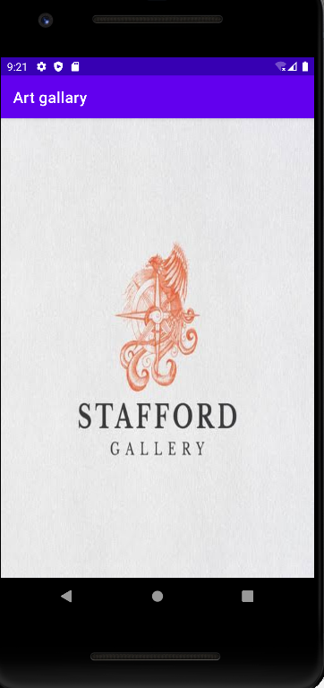

**Home/Category Screen :**

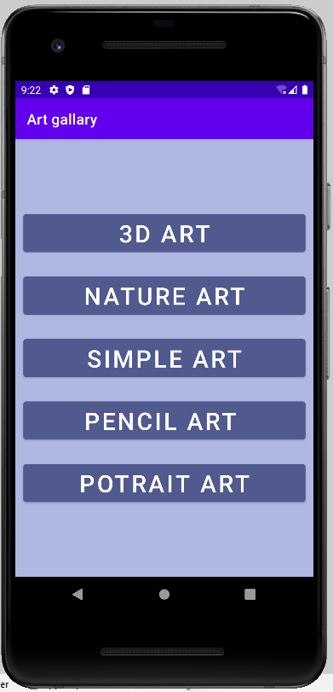

**Category Image Screen:**

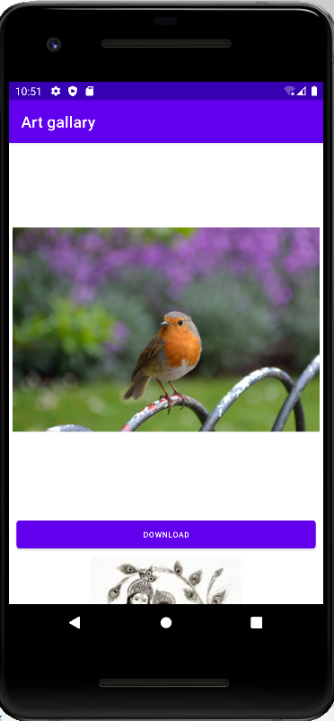

**Download Image:**

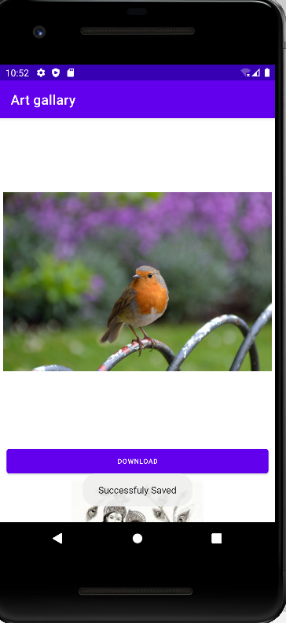

**7. TESTING**

**Types of Testing:**

**Introduction:**

Testing is a process of executing a program with the indentof finding an error.

Testing is a Crucial element of software quality assurance and presents ultimate review of specification, design and coding.

System testing is an impotent phase.

Testing represents’ an interesting anomaly for the software, thus a series of testing are performed for the proposed system before the system is ready for user acceptance testing.

A good test case is one that a high probability of finding an as in discovered error.

A Successful test is one that uncovers an as undiscovered error.

**There are various types of testing techniques are describes as follows:**

1. **Unit Testing:**

Here in this project we test each and every form and connection class of software application individually when it is completely coded.

A unit is the smallest testable part of an application benefits.

The goal of unit testing to isolate each part of the program and show that the individual part are correct a unit test provides a strict written contract that the piece of code must satisfy.

1. **Black-Box Testing:**

**Black Box**

Input Output

Black-box testing is a method of software testing.

**Typical black-box test design techniques include:**

* Decision table testing
* All pairs testing
* State transition table
* Equivalence partitioning
* Boundary value analysis

1. **White-Box Testing:**

White-box testing also known as clear-box testing, glass-box testing, transparent –box testing and structural testing is a method of testing software

**White-box test design techniques include:**

* Control flow testing
* Data flow testing
* Branch testing
* Path testing

**8. FUTURE WORK**

There are several features of the project that would be quite challenging to be added. The desirable features that quotes could have are,

* Including this app you can find easily many types of quotes. It will help us in saving time and being tired too on searching for the items.
* Another feature is allowing the application to download the quotes images. And also people can share images to any people. When people add to favorite ,they can also use like button.
* Moreover, implementing this application in iOS platform as an iPhone App is oneof the important considerations as we have many iPhone users.

**9.REFERENCES**

[1] J. Goodman, "art gallary: Who, Where and When," October 2008.[Online].

Available: http://timeuseinstitute.org/art gallary%20White%20Paper%202008.pdf. [Accessed 16 April 2017].

[2] "Agile Methodology," 4 July 2013. [Online]. Available: https://www.codeproject.com/Articles/616070/Agile-Methodology. [Accessed 16 April 2017].

[3] P. Jain, "What Makes Java a Powerful Programming Language," 11 February 2013. [Online]. Available: https://www.weblinkindia.net/blog/what-makes-java-apowerful-programming-language. [Accessed 16 April 2017].

[4] A. Rongala, "Benefits of Java over Other Programming Languages," 7 May 2015. [Online]. Available: https://www.invensis.net/blog/it/benefits-of-java-over-otherprogramming-languages/. [Accessed 16 April 2017].

[5] "Java SE Downloads," [Online]. Available: http://www.oracle.com/technetwork/java/javase/downloads/index-jsp-138363.html. [Accessed 16 April 2017].

[6] "Android Developers," [Online]. Available: https://developer.android.com/index.html. [Accessed 7 April 2017].

[7] "SoapUI," [Online]. Available: https://www.soapui.org/. [Accessed 31 March 2017].

[8] "Crashlytics, Fabric," [Online]. Available: https://fabric.io/kits/android/crashlytics/features. [Accessed 10 April 2017].

[9] C. Aliferi, "Android Barcode and Qr Scanner Example," 2 December 2014. [Online]. Available: https://examples.javacodegeeks.com/android/android-barcodeand-qr-scanner-example/. [Accessed 12 April 2017].

**10. CONCLUSION**

I have learned a lot from this project on how to develop Android Application and publishing it in real time, use Web Services using SOAP UI, reporting using chart libraries, other libraries for SDKs, requirement gathering formats.

As mentioned, other existing applications does not help in avoiding people to stand in a long checkout line, instantly searching about availability of quotes.

If people use this app in the future, they have several advantages which includes, easy downloading, liking, sharing invoices instantly as it is quite easy to misplace paper bills and organizing them in easily, particularly helpful for elderly people by avoiding them to wait for a long time .

Thank You.